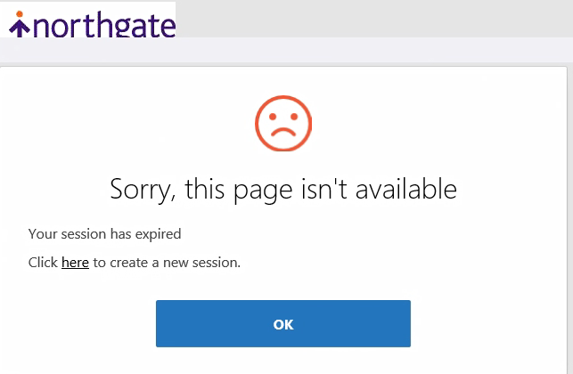

If you come to this page then you need to reset your internet options.

Select the tools icon from the web page

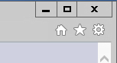

Select internet options

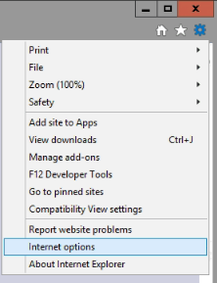

Select the Advanced tab

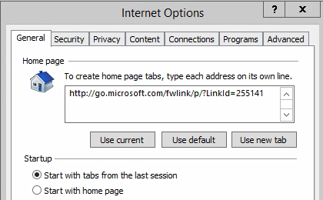

And click the Reset button

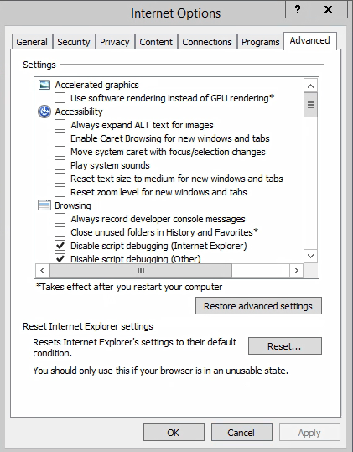

Confirm that you want to reset your internet options by clicking on the reset button

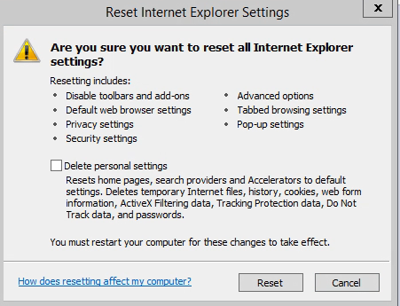

Then click on the close button

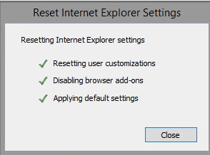

You can now try relaunching the page. (You may need to restart your computer for the change to take effect)

If that does not resolve the problem then please log the problem with [edinburghitservicedesk@cgi.com](mailto:edinburghitservicedesk@cgi.com) or through myICT