ICT System Support (Customer)
Guidance Note

System: Comino

Document Requests
When requesting a document for Comino please take into consideration the questions below, using the form as a guidance tool. Please provide as much information as possible. If a more complex document is requested we are happy to arrange a meeting to discuss your requirements.

Is the letter a new letter/amended letter/replacement letter? | New/Amend/Replace | If it is new or replacement please ensure you provide a template of the new letter/document.
Where in the document branch should it be located? |  | Council Tax > Internal > CT Case Report (C)  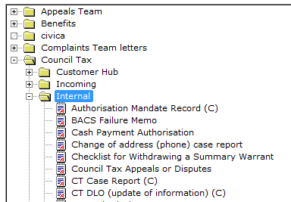
Are there Q&A’s required to populate the letter? | Yes/No | 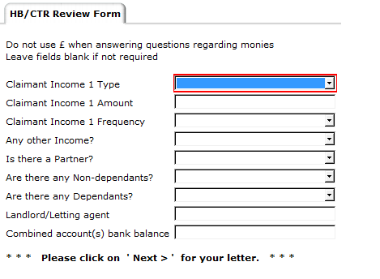
If YES,please provide Q&A and expected outcome to each |  | Include answer field into document e.g.  “You contacted us on [date provided in Q&A] and we have reviewed your application.”  Or  Only include this paragraph if the answer to the question is “yes”  [As you are self-employed we ask you to complete the form included. Please ensure that you return it ]
Is this a standalone letter, within a process or both? | Standalone/Within Process/Both
Standalone:
Does it require a process to kick off? If NO, then document will complete automatically. If YES, Is this a new process or an existing process? If NEW please provide process map details. If EXISTING, What is the name of the process?
Within Process:  What is the name of the process?  Where do you want it to sit in the process? Eg is it produced if a certain question is answered or is it always available? What stage should it be available for? |  | 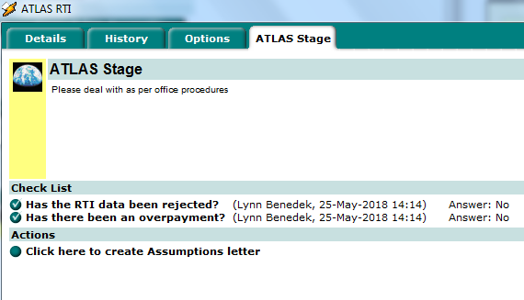
Do you require to view the change in the TEST system? | Yes/No
If YES, your TEST environment password will be sent to you.

